Reducing Customer Churn for an Internet Service Provider

Telecommunications Industry Customer churn dataset - https://www.kaggle.com/datasets/aadityabansalcodes/telecommunications-industry-customer-churn-dataset?utm_source=chatgpt.com

Data in the tables:
- CustomerID
- Gender
- SeniorCitizen
- Partner
- Dependents
- Tenure
- Phone Service
- Internet Service (DSL/Fiber/No)
- Online Security
- Online Backup
- Device Protection
- Tech Support
- Streaming TV
- Streaming Movies
- Contract
- Paperless Billing
- Payment Method
- Monthly Charges
- Total Charges
- Churn
- CLTV
- Satisfaction Score
- Churn Score
- причина ухода клиента
- категория причины ухода

ASK
• Identify the factors contributing to customer churn at an internet service provider and propose measures to reduce it.
• I am trying to address the issue of high customer churn.
The stakeholders are: the company’s CEO, the vice president of business development, and the marketing department.
My audience for this analysis is senior management (CEO, investors). Therefore, I am focusing solely on high-level business metrics (profit, ROI—Return on Investment, customer churn, budget savings). Minor details are omitted.
Presentation Guidelines:
• Minimize text and tables; maximize visual dashboards.
• The main conclusion (executive summary) must be on the very first slide.
• The presentation follows this structure: “Problem ➔ Financial Losses ➔ Our Solution ➔ Profit Forecast.”
With this data, stakeholders will be able to make decisions aimed at reducing the company’s customer churn by offering timely proposals to improve service and provide discounts.

PREPARE
All data sources used:
CustomerChurn.xlsx
Telco_customer_churn.xlsx
Telco_customer_churn_demographics.xlsx
Telco_customer_churn_location.xlsx
Telco_customer_churn_population.xlsx
Telco_customer_churn_services.xlsx
Telco_customer_churn_status.
All data is stored on a computer in a separate folder. A backup copy is stored on a USB flash drive.
No issues related to bias or reliability have been identified in this data. It complies with the ROCCC principles (Reliable, Original, Comprehensive, Current, Cited).
The data was obtained from an open source.
(https://www.kaggle.com/datasets/aadityabansalcodes/telecommunications-industry-customer-churn-dataset?utm_source=chatgpt.com), сustomer confidentiality has been maintained.
This score is calculated by Kaggle.

Completeness · 100%
- Subtitle
- Tag
- Description
- Cover Image

Credibility · 100%
- Source/Provenance
- Public Notebook
- Update Frequency

Compatibility · 50%
- License
- File Format
- File Description
- Column Description

About Dataset
The Telco customer churn data contains information about a fictional telco company that provided home phone and Internet services to 7043 customers in California in Q3. It indicates which customers have left, stayed, or signed up for their service. Multiple important demographics are included for each customer, as well as a Satisfaction Score, Churn Score, and Customer Lifetime Value (CLTV) index.
All data is present in both .csv and .xlsx file format.
This dataset contains 2 main files: 1 with less features / columns about customers (WA_Fn-UseC_-Telco-Customer-Chur table in CustomerChurn.xlsx) and one with more details (CustomerChurn.xlsx in Telco_customer_churn.xlsx), other than that it contains 5 tables:
Demographics
Location
Population
Services
Status

PROCESS

Documenting data cleaning or processing operations.

I use Dbeaver 26.1.2 to clean the data because it is a free, professional-grade program.

Before starting the data cleaning process, I checked the data by opening all the tables.

To ensure the data was clean, I used SQL.

Step 1. Data Exploration and Quality Check (CustomerChurn.xlsx)

1. Поиск дубликатов по бизнес-ключам в CustomerChurn.xlsx
Each row must correspond to a single unique customer. Let's check for duplicate Customer IDs or LoyaltyIDs:
# Checking the uniqueness of the Customer ID (expecting an empty result)
SELECT `Customer ID`, COUNT(*)
FROM CustomerChurn
GROUP BY `Customer ID`
HAVING COUNT(*) > 1;
Verification passed.

# Checking the uniqueness of the LoyaltyID (expecting an empty result)
SELECT LoyaltyID, COUNT(*)
FROM CustomerChurn
GROUP BY LoyaltyID
HAVING COUNT(*) > 1;
22 duplicate LoyaltyID values were found.
How will we fix this?
Since our Customer ID business key is completely clean and unique, we’ll do two things:
• We’ll join the tables based solely on the Customer ID field (which is perfect and contains no duplicates).
• We’ll filter out the LoyaltyID values directly in the query.
SELECT * FROM CustomerChurn
WHERE LoyaltyID IN (107296, 157658, 181463)
ORDER BY LoyaltyID;
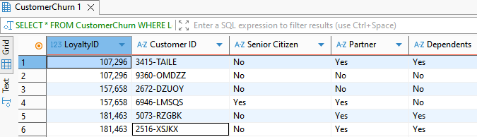
What's going on here?
• Different customers under the same LoyaltyID: For example, the first two rows for LoyaltyID = 107,296 show completely different customers:
1. The first customer is 3415-TAILE (not elderly, married, with dependents).
2. The second customer is 9360-OMDZZ (not elderly, single, no dependents).
• The same applies to the other pairs (157,658 and 181,463)—they represent completely unique individuals with different marital statuses and unique Customer IDs.
What conclusion have we reached?
1. The Customer ID is our only reliable reference point. This field is error-free, and we will use it to link the data.
2. The LoyaltyID contains technical errors. A glitch occurred in the loyalty system, causing different people to be assigned the same loyalty card numbers.
Let’s create a cleaned, single table called `Cleaned_CustomerChurn`

CREATE VIEW Cleaned_CustomerChurn AS
SELECT
-- 1. Unique customer ID (remove any random spaces)
TRIM(`Customer ID`) AS `Customer ID`,
-- 2. Correct the LoyaltyID: if it is duplicated across different people, set it to zero (set it to NULL),
-- to prevent false relationships from occurring in Power BI. Leave unique IDs as they are.
CASE
WHEN LoyaltyID IN (
SELECT LoyaltyID
FROM CustomerChurn
GROUP BY LoyaltyID
HAVING COUNT(*) > 1
) THEN NULL
ELSE LoyaltyID
END AS LoyaltyID,

-- 3. Standardize text flags (convert to lowercase and remove spaces)
TRIM(LOWER(Partner)) AS Partner,
TRIM(LOWER(Dependents)) AS Dependents,

-- 4. Length of relationship with the client (leave as is if there are no negative values)
Tenure,

-- 5. Standardize the “Senior Citizen” status to a uniform text format of ‘Yes’ / “No”
CASE
WHEN `Senior Citizen` = 'Yes' OR `Senior Citizen` = '1' OR `Senior Citizen` = 1 THEN 'Yes'
ELSE 'No'
END AS `Senior Citizen`,

-- 6. Copy the remaining columns of the customer profile without making any changes
`Phone Service`,
`Multiple Lines`,
`Internet Service`,
`Online Security`,
`Online Backup`,
`Device Protection`,
`Tech Support`,
`Streaming TV`,
`Streaming Movies`,
Contract,
`Paperless Billing`,
`Payment Method`,
`Monthly Charges`,
`Total Charges`,
Churn

FROM CustomerChurn
# Filter out empty or invalid rows by customer ID, should they appear
WHERE `Customer ID` IS NOT NULL AND `Customer ID` != '';
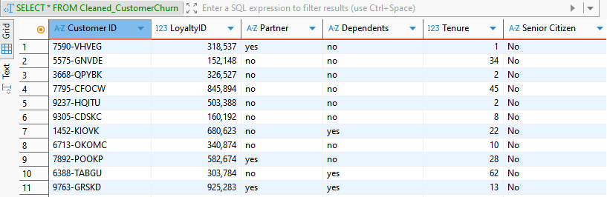
In the Cleaned_CustomerChurn view:
• The Partner and Dependents columns have now been standardized to lowercase (yes/no).
• The Senior Citizen column has been standardized to a clear text format (No).
• All problematic duplicate LoyaltyIDs have been removed, while unique ones have been retained in their original locations.

Step 2. Data Exploration and Quality Check (Telco_customer_churn.xlsx)
Spaces and duplicates have been removed in Google Docs.
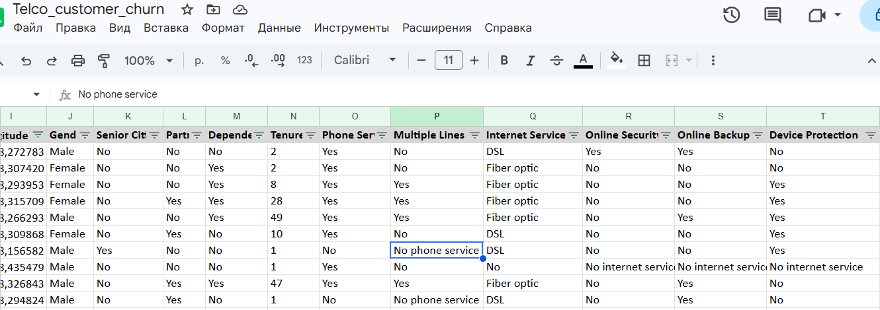
The non-standard entries “No phone service” and “No internet service” have been replaced with “No.”
# Checking the uniqueness of the Customer ID (expecting an empty result) in Dbeaver:
SELECT `Customer ID`, COUNT(*)
FROM CustomerChurn
GROUP BY `Customer ID`
HAVING COUNT(*) > 1;
Verification passed.

# Checking the uniqueness of the LoyaltyID (expecting an empty result)
SELECT LoyaltyID, COUNT(*)
FROM CustomerChurn
GROUP BY LoyaltyID
HAVING COUNT(*) > 1;

Financial QA: Checking “Total Charges” for Empty Rows and Anomalies
A very common issue is empty values (or blank fields). These typically occur for new customers whose “Tenure Months” is 0.
Let's check if there are any rows where the charges are missing, equal to zero, or negative:
SELECT
SUM(CASE WHEN `Total Charges` IS NULL OR `Total Charges` = '' THEN 1 ELSE 0 END) AS empty_total_charges,
SUM(CASE WHEN `Total Charges` < 0 THEN 1 ELSE 0 END) AS negative_total_charges,
COUNT(*) AS total_rows
FROM Telco_customer_churn;
Verification passed.

Logical QA: Verifying the Accuracy of Rates and Payments
Let's check the logic of the calculations: Monthly Charges multiplied by Tenure Months should be approximately equal to Total Charges. We're looking for obvious technical errors where the total amount does not match the monthly amount:
SELECT CustomerID, `Tenure Months`, `Monthly Charges`, `Total Charges`,
ABS((`Monthly Charges` * `Tenure Months`) - `Total Charges`) AS difference
FROM Telco_customer_churn
WHERE `Tenure Months` > 0
ORDER BY difference DESC
LIMIT 10;
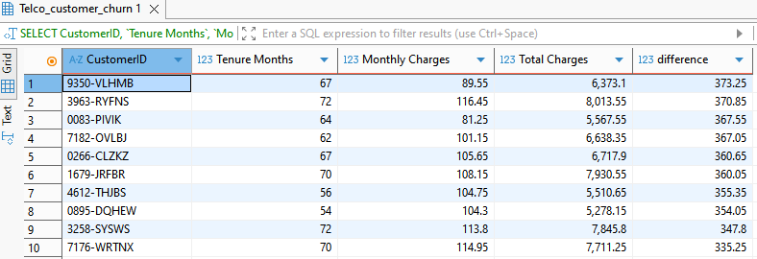

Is this a mistake?
No, this is completely normal. A difference of $5–6\%$ over the long term (60–70 months of service) can easily be explained by business logic:
• The customer may have temporarily switched rate plans or added or removed additional services.
• One-time discounts, taxes, or late payment penalties may have been applied.
If the difference were in the tens of thousands with a monthly payment of $100, that would be an anomaly. In this case, the calculations look entirely natural and plausible.

Verifying Metrics and Scales (Churn Score and Churn Value)
The Churn Value column must strictly take the values 0 or 1 (churned/retained). The Churn Score (probability of churn) is typically measured on a scale from 0 to 100. Let’s check their ranges:
SELECT
MIN(`Churn Value`) AS min_value,
MAX(`Churn Value`) AS max_value,
MIN(`Churn Score`) AS min_score,
MAX(`Churn Score`) AS max_score
FROM Telco_customer_churn;

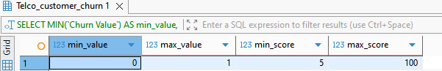
What these results tell us:
• Churn Value (0 to 1): As expected, this is a strictly binary scale. 0 means the customer remained with the company, and 1 means they left. There is no “noise” (such as negative numbers or empty values).
• Churn Score (from 5 to 100): The probability of churn is measured on a scale from 0 to 100%. The minimum risk for customers in this table is 5%, and the maximum is 100%. Everything fits within the framework of standard mathematical logic; no anomalies (such as a score of 150 or -10) were detected.

Geographic QA: State Validation
Let's verify that there are no “junk” states in the database:
SELECT State, COUNT(*)
FROM Telco_customer_churn
GROUP BY State;
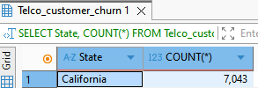
There is absolutely no junk data, missing entries, or other regions in the geographic data. Every row pertains strictly to a single state.

Step 3. Data Exploration and Quality Check
(Telco_customer_churn_demographics.xlsx)
A check of the Telco_customer_churn_demographics.xlsx file in Google Docs revealed no duplicates or blank cells.

Test for Age Validity
Customer ages must be realistic. We are looking for possible typos (for example, an age of 0, a negative age, or an age greater than 120):
SELECT MIN(Age) AS min_age, MAX(Age) AS max_age
FROM Telco_customer_churn_demographics;
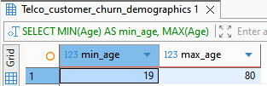
Verification passed.

Cross-Check: Age vs. Under 30
The table includes an “Under 30” flag. Let's check to see if there's a system error where a 45-year-old person has a “Yes” status, or vice versa:
SELECT Age, `Under 30`, COUNT(*)
FROM Telco_customer_churn_demographics
WHERE (Age < 30 AND `Under 30` != 'Yes')
OR (Age >= 30 AND `Under 30` = 'Yes')
GROUP BY Age, `Under 30`;
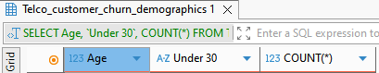
Verification passed.

Cross-Check: Married vs. Number of Dependents
Logical check for dependents: If the client’s “Dependents” field is set to “No,” then the “Number of Dependents” must be exactly 0. Conversely, if it is set to “Yes,” the number must be greater than zero.
SELECT Dependents, `Number of Dependents`, COUNT(*)
FROM Telco_customer_churn_demographics
WHERE (Dependents = 'No' AND `Number of Dependents` > 0)
OR (Dependents = 'Yes' AND `Number of Dependents` = 0)
GROUP BY Dependents, `Number of Dependents`;
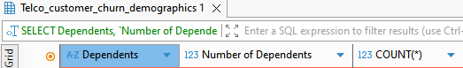
Verification passed.

Step 4. Data Exploration and Quality Check (Telco_customer_churn_location.xlsx)
A check in Google Docs revealed no duplicates or blank cells.

Test for Zip Code Length and Range
In the U.S., a Zip Code must consist strictly of 5 digits. Let’s check for Zip Codes that are too short, too long, or empty:
SELECT
MIN(`Zip Code`) AS min_zip,
MAX(`Zip Code`) AS max_zip,
COUNT(*) FILTER(WHERE LENGTH(CAST(`Zip Code` AS TEXT)) != 5) AS invalid_length_count
FROM Telco_customer_churn_location;
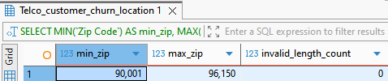
Verification passed.

Coordinate Validity Test (Latitude and Longitude)
Coordinates must fall within a strictly defined range for the state of California (latitude approximately from 32 to 42, longitude from -124 to -114). Let’s check whether the table contains any zero coordinates or values that are on the other side of the planet:
SELECT
MIN(Latitude) AS min_lat,
MAX(Latitude) AS max_lat,
MIN(Longitude) AS min_lon,
MAX(Longitude) AS max_lon
FROM Telco_customer_churn_location;
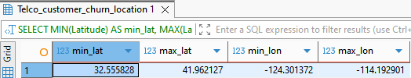
Verification passed.

Logical Relationship Test: Coordinates vs. the “Lat Long” Text Field
The table contains a combined Lat Long field (for example, 34.02381, -118.156582) and separate Latitude and Longitude fields. Let’s check whether they match in meaning to rule out a technical glitch when splitting the columns:
SELECT `Lat Long`, Latitude, Longitude
FROM Telco_customer_churn_location
WHERE `Lat Long` NOT LIKE '%' || ROUND(Latitude, 4) || '%'
OR `Lat Long` NOT LIKE '%' || ROUND(Longitude, 4) || '%'
LIMIT 10;
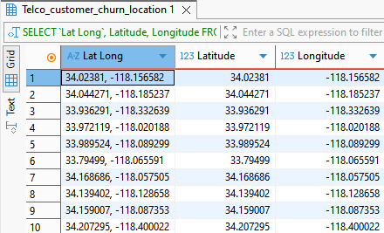
Lat Long, Latitude, and Longitude match perfectly across all 10 rows. The fact that they were included in the sample at all is due to the specific rounding conventions used in the text. The key point is that there are no significant discrepancies or mismatches in the data (such as one city listed in one column and the coordinates of another city in another column).

Step 5. Data Exploration and Quality Check (Telco_customer_churn_population.xlsx)
A check in Google Docs revealed no duplicates or blank cells.

Test for Extreme Values in Population
The population in residential areas with a ZIP code cannot be negative or equal to zero. We’ll also check the maximum values to rule out extra zeros or formatting errors:
SELECT
MIN(Population) AS min_pop,
MAX(Population) AS max_pop,
COUNT(*) FILTER (WHERE Population <= 0) AS zero_or_negative_pop
FROM Telco_customer_churn_population;
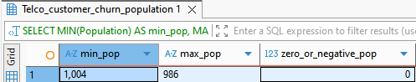
  - min_pop = 1 004
  - max_pop = 986
What's the problem: The maximum value (986) turned out to be less than the minimum (1,004). In the normal world of mathematics, this cannot happen.
Why did this happen: The database treats the Population column not as numbers, but as text (VARCHAR/TEXT). When sorting text, “986” is considered greater than “1,004” because the nine comes after the one.
Let’s run a test query by removing the spaces (or commas) that turned the numbers into text:
SELECT
MIN(CAST(REPLACE(REPLACE(Population, ' ', ''), ',', '') AS INTEGER)) AS real_min_pop,
MAX(CAST(REPLACE(REPLACE(Population, ' ', ''), ',', '') AS INTEGER)) AS real_max_pop
FROM Telco_customer_churn_population;
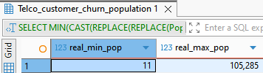
Now, in Power BI, all we need to do is change the data type of the Population column to “Integer.”

Cross-check: Linking Indexes to the Location Table
The most important thing for the analysis is that the indexes from this table match the indexes from the Telco_customer_churn_location table, which we checked in the previous step. Let’s check to see if there are any “missing” indexes that would cause some of the data to appear as “Blank” in Power BI when the tables are linked:
SELECT COUNT(DISTINCT l.`Zip Code`) AS missing_zip_codes
FROM Telco_customer_churn_location l
LEFT JOIN Telco_customer_churn_population p ON l.`Zip Code` = p.`Zip Code`
WHERE p.`Zip Code` IS NULL;
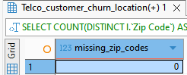
Verification passed.

Step 6. Data Exploration and Quality Check (Telco_customer_churn_services.xlsx)
A check in Google Docs revealed no duplicates or blank cells.

Financial logic test: Total Revenue
In a valid database, total revenue should be calculated as the sum of contract charges minus refunds. Let’s check the formula:
Total Revenue = Total Charges − Total Refunds + Total Extra Data Charges + Total Long Distance Charges
Since the data contains commas, we’ll apply REPLACE on the fly to check which records don’t match the calculation:
SELECT
`Customer ID`, `Total Charges`, `Total Refunds`,
`Total Extra Data Charges`, `Total Long Distance Charges`, `Total Revenue`
FROM Telco_customer_churn_services
WHERE ABS(
CAST(REPLACE(REPLACE(`Total Charges`, ' ', ''), ',', '.') AS REAl) -
CAST(REPLACE(REPLACE(`Total Refunds`, ' ', ''), ',', '.') AS REAL) +
CAST(REPLACE(REPLACE(`Total Extra Data Charges`, ' ', ''), ',', '.') AS REAL) +
CAST(REPLACE(REPLACE(`Total Long Distance Charges`, ' ', ''), ',', '.') AS REAL) -
CAST(REPLACE(REPLACE(`Total Revenue`, ' ', ''), ',', '.') AS REAL)
) > 1.0
LIMIT 10;
We allow for a difference of $1 to account for minor rounding errors. If the query returns an empty table, the formula matches perfectly.

Logical Test: Internet Packages vs. Downloaded Traffic
The table contains an “Internet Service” (Yes/No) column and an “Avg Monthly GB Download” column. The logic is simple: if a customer does not have internet service, the traffic should be exactly zero. Let’s check for anomalies:
SELECT COUNT(*) AS internet_logic_errors
FROM Telco_customer_churn_services
WHERE (`Internet Service` = 'No' AND CAST(`Avg Monthly GB Download` AS INTEGER) > 0)
OR (`Internet Service` = 'Yes' AND CAST(`Avg Monthly GB Download` AS INTEGER) IS NULL);
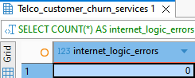
Verification passed.

Logic Test: Phone Service vs. Calls
The “Phone Service (Yes/No)” column and “Avg Monthly Long Distance Charges.” If there is no phone, the charge must be exactly 0:
SELECT COUNT(*) AS phone_logic_errors
FROM Telco_customer_churn_services
WHERE `Phone Service` = 'No' AND `Avg Monthly Long Distance Charges` > 0;
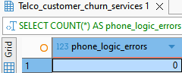
Verification passed.

Step 7. Data Exploration and Quality Check (Telco_customer_churn_status.xlsx)
A check in Google Docs confirmed that there were no duplicates or blank cells.

Logic Test for Churned Customers (Churn Value vs. Churn Reason)
For every customer who has churned (Churn Value = 1), a category (Churn Category) and a reason for churn (Churn Reason) must be specified. Conversely, for loyal customers (Churn Value = 0 or Stayed/Joined status), these fields must be empty. Let’s check for any logical inconsistencies:
SELECT COUNT(*) AS status_logic_errors
FROM Telco_customer_churn_status
WHERE (`Churn Value` = 1 AND (`Churn Reason` IS NULL OR `Churn Reason` = ''))
OR (`Churn Value` = 0 AND (`Churn Reason` IS NOT NULL AND `Churn Reason` != ''));
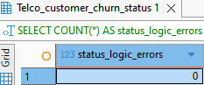
Verification passed.

Test for Consistency Between Churn Flags

(Customer Status vs. Churn Value)
The table contains a text field for “Customer Status” and a binary field for “Churn Value.” Let's verify that they do not contradict each other (if the status is “Churned,” the value must be exactly 1, and if it is ‘Stayed’ or “Joined,” the value must be exactly 0):
SELECT COUNT(*) AS flag_mismatch_errors
FROM Telco_customer_churn_status
WHERE (`Customer Status` = 'Churned' AND `Churn Value` != 1)
OR (`Customer Status` IN ('Stayed', 'Joined') AND `Churn Value` != 0);
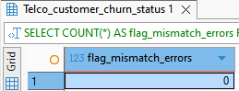
Verification passed.

Testing for Extreme Values in Metrics

(Satisfaction Score and Churn Score)
Satisfaction scores are typically measured on a scale from 1 to 5, while churn probability scores range from 0 to 100. Let’s check whether our metrics fall outside their expected ranges (for example, whether there are any negative values or abnormally high numbers):
SELECT
MIN(`Satisfaction Score`) AS min_satisfaction,
MAX(`Satisfaction Score`) AS max_satisfaction,
MIN(`Churn Score`) AS min_churn_score,
MAX(`Churn Score`) AS max_churn_score
FROM Telco_customer_churn_status;
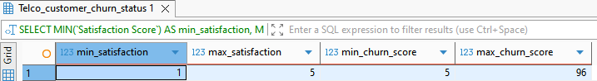
Verification passed.

ANALYZE
I’m starting my data analysis in Visual Studio Code.
To solve the problem of high churn, we need to conduct three consecutive analyses:

1. Profile of Churning Customers (Segmentation):
o What to analyze: The relationship between demographics (Gender, Married, Under 30, Senior Citizen, Dependents) and churn status (Churn Label / Churn Value).
o Why: To understand who is in our risk zone. For example: “Young, single people under 30 are most likely to churn.”
I create a file named analysis.ipynb
import pandas as pd

# 1. Reading files directly from the current folder
demo = pd.read_csv("Telco_customer_churn_demographics.csv")
status = pd.read_csv("Telco_customer_churn_status.csv")

# 2. Clean up column names and IDs
demo.columns = demo.columns.str.strip()
status.columns = status.columns.str.strip()

demo['Customer ID'] = demo['Customer ID'].astype(str).str.strip()
status['Customer ID'] = status['Customer ID'].astype(str).str.strip()

# 3. Combining Tables
df = pd.merge(demo, status, on="Customer ID", how="inner")

# Convert Churn Value to a numeric type (1 / 0)
df['Churn Value'] = pd.to_numeric(df['Churn Value'], errors='coerce').fillna(0)

# 4. Grouping by Demographic Factors
churn_portrait = df.groupby(["Under 30", "Senior Citizen", "Married", "Dependents"])["Churn Value"].agg(
Total_Customers='count',
Churned_Customers='sum',
Churn_Rate_Percent=lambda x: round(x.mean() * 100, 2)
).reset_index()

# 5. Sort by outflow percentage in descending order
churn_portrait = churn_portrait.sort_values(by="Churn_Rate_Percent", ascending=False)

# 6. Save to a CSV file
churn_portrait.to_csv("demographic_churn_portrait.csv", index=False)

# Displaying a table
churn_portrait
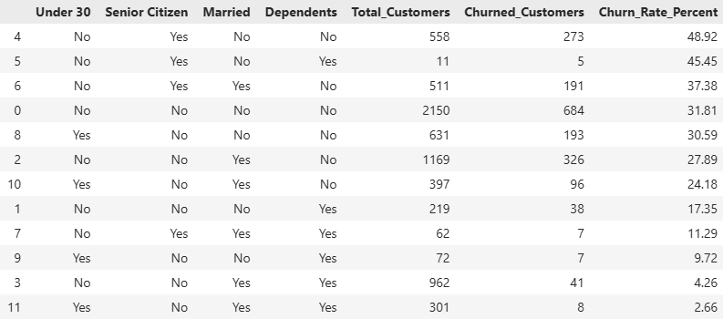

Conclusions:
1. Profile of High-Risk Clients (Highest Churn Rate)
Older adults living alone (unmarried, with no dependents) have the highest churn rate—48.92% (nearly half of them leave!).
In second place are older adults with dependents but without a spouse (45.45%).
Key factor: Older adults (older adult = “Yes”) without family ties are, overall, the most vulnerable customer segment.
2. Profile of clients with the lowest risk (most loyal)
Young people and middle-aged families with dependents (married = “Yes,” dependents = “Yes”) show the lowest churn rates:
Young families under 30: churn rate of 2.66%.
Families not classified as elderly: churn rate of 4.26%.
Key factor: Having both a partner and dependents ensures high loyalty and stability in service usage.
3. Summary of Key Factors
Having dependents and being married act as powerful factors that curb customer churn across all age groups. Single customers (especially older adults) without dependents should be immediately offered targeted retention offers.

2 Analysis of the Product Portfolio and Service Quality:
o What to investigate: Which services are subscribed to by those who are churning (Internet Type—fiber/cable, Streaming Movies/Music, Online Security, Premium Tech Support).
o Why management needs this: To identify “problem” products. If churn is abnormally high among fiber users (Fiber
import pandas as pd

# 1. Data Upload
services = pd.read_csv("Telco_customer_churn_services.csv")
status = pd.read_csv("Telco_customer_churn_status.csv")

# 2. Joining by Customer ID
df = pd.merge(services, status, on="Customer ID")

# Function for calculating outflow
def analyze_churn(column_name):
return df.groupby(column_name)["Churn Value"].agg(
Total_Customers='count',
Churned_Customers='sum',
Churn_Rate_Percent=lambda x: round(x.mean() * 100, 2)
).reset_index().sort_values(by="Churn_Rate_Percent", ascending=False)

# 3. Displaying Results
print("=== 1. CHURN BY INTERNET TYPE ===")
print(analyze_churn("Internet Type").to_string(index=False))

print("\n=== 2. CHURN BY ONLINE SECURITY ===")
print(analyze_churn("Online Security").to_string(index=False))

print("\n=== 3. CHURN BY PREMIUM TECH SUPPORT ===")
print(analyze_churn("Premium Tech Support").to_string(index=False))

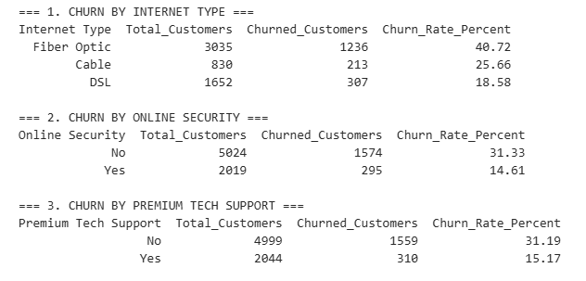

Conclusions:
1. Issue No. 1: Fiber Optic — the main driver of churn
• Fiber Optic churn stands at 40.72% (1,236 lost customers out of 3,035).
• For comparison: the churn rate for DSL is only 18.58%, and for cable, 25.66%.
• Conclusion: Fiber Optic is positioned as a premium, high-speed product, but it is losing every other customer.
• Hypothesis: The problem lies either in unstable connection quality (frequent disconnections/speed drops) or in inflated expectations regarding price (high monthly fees coupled with poor service).
2. Impact of Technical Support and Security (Online Security & Tech Support)
• Online Security:
o Churn WITHOUT the service: 31.33%
o Churn WITH the service: 14.61% (churn is more than 2 times lower!)
• Premium Tech Support:
o Churn WITHOUT the service: 31.19%
o Churn WITH the service: 15.17% (churn is more than 2 times lower!)
Conclusion for management: The availability of premium technical support and security services directly “retains” customers. When a fiber-optic user experiences a technical failure and doesn’t have prompt technical support on hand, they don’t try to figure out the problem—they simply switch to competitors.

3 Financial and Contract Analysis (Churn Economics):
What to Investigate: The impact of contract type (Contract—monthly or annual), cost (Monthly Charges, Total Charges), and payment methods (Payment Method, Paperless Billing) on churn.
This analysis uses data from the Telco_customer_churn_services.csv and Telco_customer_churn_status.csv files.
import pandas as pd

# 1. Loading data from the current folder
services = pd.read_csv("Telco_customer_churn_services.csv")
status = pd.read_csv("Telco_customer_churn_status.csv")

# Removing random spaces from column names
services.columns = services.columns.str.strip()
status.columns = status.columns.str.strip()

# 2. Joining by Customer ID
df = pd.merge(services, status, on="Customer ID")

# Convert the numerical financial columns and outflow to the correct data type
df['Monthly Charge'] = pd.to_numeric(df['Monthly Charge'], errors='coerce')
df['Total Revenue'] = pd.to_numeric(df['Total Revenue'], errors='coerce')
df['Churn Value'] = pd.to_numeric(df['Churn Value'], errors='coerce').fillna(0)

# Utility function for calculating sales and average check
def analyze_financial_factor(column_name):
res = df.groupby(column_name)["Churn Value"].agg(
Total_Customers='count',
Churned_Customers='sum',
Churn_Rate_Percent=lambda x: round(x.mean() * 100, 2)
).reset_index().sort_values(by="Churn_Rate_Percent", ascending=False)

# Add the average check for each group
avg_charge = df.groupby(column_name)['Monthly Charge'].mean().round(2).reset_index()
res = pd.merge(res, avg_charge, on=column_name)
res.rename(columns={'Monthly Charge': 'Avg_Monthly_Charge_$'}, inplace=True)
return res

# 3. Calculating Metrics
df_contract = analyze_financial_factor("Contract")
df_payment = analyze_financial_factor("Payment Method")
df_paperless = analyze_financial_factor("Paperless Billing")

# 4. Comparison of Average Check for Lost Customers vs. Retained Customers
financial_summary = df.groupby("Customer Status")["Monthly Charge"].agg(
Total_Customers='count',
Avg_Monthly_Charge='mean',
Median_Monthly_Charge='median'
).reset_index().round(2)

# 5. Display the results on the screen
print("=== 1. CHURN BY CONTRACT TYPE ===")
print(df_contract.to_string(index=False))

print("\n=== 2. CHURN BY PAYMENT METHOD ===")
print(df_payment.to_string(index=False))

print("\n=== 3. CHURN BY PAPERLESS BILLING ===")
print(df_paperless.to_string(index=False))

print("\n=== 4. MONTHLY CHARGES: CHURNED VS STAYED ===")
print(financial_summary.to_string(index=False))

# 6. SAVE RESULTS TO CSV (fixed: added paperless saving)
df_contract.to_csv("churn_by_contract.csv", index=False)
df_payment.to_csv("churn_by_payment_method.csv", index=False)
df_paperless.to_csv("churn_by_paperless_billing.csv", index=False)
financial_summary.to_csv("financial_summary_by_status.csv", index=False)

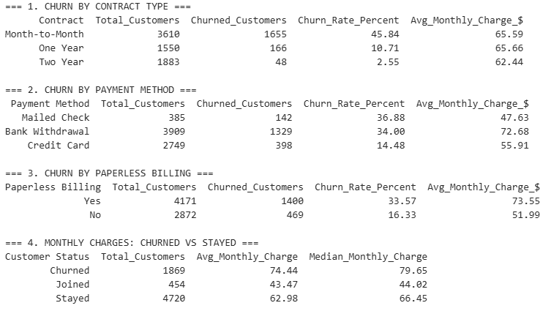

Actual Amounts of Financial Losses (Lost Revenue)
The status.csv file contains data for the Quarter field, while the financial metrics (Monthly Charge and Total Revenue) are stored in services.csv.
import pandas as pd
# 1. Data Upload
services = pd.read_csv("Telco_customer_churn_services.csv")
status = pd.read_csv("Telco_customer_churn_status.csv")

# Removing random spaces from column names
services.columns = services.columns.str.strip()
status.columns = status.columns.str.strip()

# 2. Joining by Customer ID
df = pd.merge(services, status, on="Customer ID", how="inner")

# Converting Financial Columns to Numeric Format
df['Monthly Charge'] = pd.to_numeric(df['Monthly Charge'], errors='coerce').fillna(0)
df['Total Revenue'] = pd.to_numeric(df['Total Revenue'], errors='coerce').fillna(0)
df['Churn Value'] = pd.to_numeric(df['Churn Value'], errors='coerce').fillna(0)

# If the “Quarter” column is missing, restore it to its default value as “Q3”
if 'Quarter' not in df.columns:
df['Quarter'] = 'Q3'

# Filter only for customers who have left
churned_df = df[df['Churn Value'] == 1].copy()

# 3. QUARTERLY CALCULATION OF LOSSES
quarterly_loss = churned_df.groupby('Quarter').agg(
Churned_Customers=('Customer ID', 'count'),
Lost_Monthly_Revenue_MRR=('Monthly Charge', 'sum'),
Lost_Total_Revenue=('Total Revenue', 'sum'),
Avg_Lost_Monthly_Charge=('Monthly Charge', 'mean')
).reset_index().round(2)

# Add the annual loss forecast (MRR * 12 months)
quarterly_loss['Lost_Annual_Run_Rate_$'] = (quarterly_loss['Lost_Monthly_Revenue_MRR'] * 12).round(2)

# 4. TOTAL LINE (ANNUAL CALCULATION)
yearly_loss = pd.DataFrame([{
'Quarter': 'TOTAL YEARLY (Annual Loss)',
'Churned_Customers': churned_df['Customer ID'].count(),
'Lost_Monthly_Revenue_MRR': churned_df['Monthly Charge'].sum().round(2),
'Lost_Total_Revenue': churned_df['Total Revenue'].sum().round(2),
'Avg_Lost_Monthly_Charge': churned_df['Monthly Charge'].mean().round(2),
'Lost_Annual_Run_Rate_$': (churned_df['Monthly Charge'].sum() * 12).round(2)
}])

# 5. Consolidate the report
final_loss_report = pd.concat([quarterly_loss, yearly_loss], ignore_index=True)

# 6. Saving in CSV
final_loss_report.to_csv("financial_loss_analysis.csv", index=False)

# Displaying Results on the Screen
print("=== FINANCIAL LOSS ANALYSIS (LOST REVENUE) ===")
print(final_loss_report.to_string(index=False))

Breakdown of Financial Losses:
1. $139,130.85 per month (Lost Monthly Revenue / MRR)
• Every month, the company loses $139,100 in recurring revenue due to the loss of these 1,869 customers.
• This is pure lost profit that goes directly to competitors.
2. $1,669,570.20 per year (Lost Annual Run Rate)
• Key point: If nothing changes, losing these customers costs the company nearly $1.67 million annually!
• Why this analysis was conducted: Even if the retention strategy you’ve developed (such as discounts for annual contracts or the inclusion of free technical support) helps retain at least 20%–30% of churning customers, the company will save between $330,000 and $500,000 per year.
3. $3,684,459.82 LTV Losses (Lost Total Revenue)
• In total, over the course of their tenure, these lost customers have already generated $3.68 million.
• These were LTV-generating customers (with a high average transaction value of $74.44) who used the services for a long time but eventually encountered a problem (such as issues with fiber optic quality) and left.

SHARE
Supporting Visualizations and Key Findings
All visualizations you can find in my slide show.

Customer Profile Analysis
1. High-Risk Customer Profile (Highest Churn Rate)
• Senior citizens living alone (single, no dependents) have the highest churn rate at 48.92% (nearly half of them leave!).
• Second highest is senior citizens with dependents but no spouse (45.45%).
• Key Factor: Senior citizens (Senior Citizen = Yes) without family ties are overall the most vulnerable customer segment.
2. Lowest-Risk Customer Profile (Most Loyal)
• Young/middle-aged families with dependents (Married = Yes, Dependents = Yes) show the lowest churn rates:
o Young families under 30: 2.66% churn rate.
o Non-senior families: 4.26% churn rate.
• Key Factor: Having both a partner and dependents creates strong retention and service stability.
3. Core Driver Summary
Dependents and marriage act as strong buffers against churn across all age categories. Single customers (especially senior citizens) without dependents require immediate, targeted retention offers.
The high churn rate associated with electronic receipts is not due to the receipts themselves, but rather to the fact that they are chosen by customers on higher-tier plans ($73.55 vs. $51.99), who are more price-sensitive.
The company is losing its highest-paying (ARPU) customers! It’s not those looking for “cheap service” who are leaving, but those who pay $75–80 per month and aren’t receiving the expected quality of service or support.

Analysis of Churn (Financial & Contract Churn)
1. Contract Type — The Main Retention Factor
• Month-to-Month (monthly payment): Abnormally high churn rate — 45.84% (nearly one in two customers leaves!).
• One Year: Churn drops to 10.71%.
• Two Year: Churn is practically zero—only 2.55%.
Conclusion: Monthly customers pay exactly the same amount ($65.59) as customers with a one-year contract ($65.66), but nothing legally binds them. Switching customers to long-term contracts is the #1 strategy for combating churn.
2. Payment Method (Payment Method)
• Mailed Check & Bank Withdrawal: High churn—36.88% and 34.00%, respectively.
• Credit Card: Low churn—14.48% (more than half as low!).
Conclusion: Customers who pay by credit card are the most loyal. Bank Withdrawal shows a high churn rate, as it is often associated with payment delays, unexpected debits, or strict limits.
3. Paperless Billing
• Paperless Billing = Yes: Churn rate 33.57% (average check $73.55).
• Paperless Billing = No: Churn rate of 16.33% (average receipt of $51.99).
Conclusion: The high churn rate associated with paperless billing is not due to the billing method itself, but rather because it is chosen by customers with higher-tier plans ($73.55 vs. $51.99), who are more price-sensitive.
4. Price Level (Monthly Charges: Churned vs. Stayed) — Key Insight
• Churned customers: Average monthly charge is $74.44 (median $79.65).
• Stayed customers: Average monthly

ACT
Recommendations Based on My Analysis

Business Recommendations (Actionable Insights)
1. Fiber Optic Infrastructure Audit: Instruct the technical department to inspect the equipment and verify signal stability on the fiber-optic lines.
2. Bundling: Include Premium Tech Support and Online Security in the basic fiber optic package (or offer them free of charge for the first 3–6 months to all new fiber optic users).
3. Proactive Service: Implement automated monitoring of connection outages for Fiber Optic so that technical support contacts the customer before they decide to cancel their contract.
4. Discounts for Long-Term Contracts: Offer a $5–10 monthly discount when switching from a Month-to-Month plan to a 1-Year or 2-Year plan. This is more financially beneficial than losing $74.44/month on each customer who leaves.
5. Loyalty program for higher-priced plans: For customers with a bill >$70, introduce free premium options (e.g., free Premium Tech Support) to reduce churn.
6. Incentives for linking credit cards: Offer a one-time bonus for linking credit card payments instead of paper checks or direct debits from bank accounts. Implement automatic credit card payments as the preferred payment method (for example, offer a small bonus for linking a credit card).

